ONLINE SUPPLEMENTAL APPENDICES

“Exploring mediating pathways between school segregation and health:
Evidence on peer prejudice and health behaviors”

- Sample Selection
  - Figure e1. Sample flow chart

- Operationalizing school racial composition
  - Table e1. Number of schools in each group, by category
  - Figure e2. Distribution of school racial compositions (at the school level), by whether they were above vs. below the median % Black
  - Figure e3. Distribution of school racial compositions (at the school level), by whether they were above vs. below the median % White

- Measurement analysis: perceived prejudice and feelings of exclusion
  - Table e2. Correlation matrix between exclusion questions
  - Figure e4. Scree plot of eigenvalues from an exploratory factor analysis of 6 exclusion items
  - Table e3. Exploratory factor analysis loadings for a 1-factor model
  - Table e4. Exploratory factor analysis loadings for a 2-factor model

- Sensitivity Analyses
  - Figure e5. Forest plot: Associations between school segregation and feelings of exclusion, by race and school racial composition
  - Table e5. Wave 1 sample characteristics
  - Figure e6. Forest plot: Associations between school segregation and students’ close friends’ health behaviors, by race and school racial composition
  - Table e6. Missing-ness check: Peer network health behaviors
  - Table e7. Missing-ness check: Peer prejudice

Appendix I.
Sample Selection

Figure e1. Sample Flow Chart

Add Health In-school sample
N = 90,118
Outcomes not missing
N = 68,947
Covariates not missing
N = 53,275
Has school information and are public schools
N = 74,281
Has district school segregation data
N = 78,776
Missing respondent identifier
N = 85,627
Add Health Wave I in-home sample & has district school segregation data
N = 20,745
Has school information and are public schools
N = 18,904
Outcomes not missing
N = 18,669
Covariates not missing
N = 12,793
In Schools Below Median % White
N = 29,236
In Schools Above Median % White
N = 24,039
In Schools Below Median % White
N = 7,046
In Schools Above Median % White
N = 5,747
In-school
Wave I
Appendix II.
Operationalizing school racial composition

Summarizing school racial composition into a single variable is complex, and each potential choice has drawbacks. Of note were two considerations: which categorization best separated predominantly White schools from schools serving a greater proportion of students of color, and which categorizations would retain enough schools within each group to have decent statistical power for all values of a given school racial composition variable. Below, we describe how we calculated underlying school racial composition variables, as well as how we selected ‘above vs. below the median value of % White across Add Health schools’ for our main analysis.

First, we calculated the percentage of each school that was Asian or Pacific Islander (non-Hispanic), Black (non-Hispanic), Hispanic, Native American (non-Hispanic), or White (non-Hispanic). We did so by taking the average of dummy variables for each racial/ethnic group across all members of Add Health’s in-school sample, by school. While this is not administrative data but rather derived from Add Health’s sample, these variables accorded well with Add Health stratification variables derived from administrative data. These stratification variables measured the percentage of students in the high schools of a given district that were non-Hispanic White, allowing us an imperfect benchmark for validating our sample-derived “percentage White” values.

Second, we examined the racial/ethnic make-up of schools above and below different potential thresholds across Add Health’s five racial/ethnic groups. Since the major policies addressed by Supreme Court cases on integration focused on Black and White students, we primarily used these groups to create our categories. Potential thresholds included:

- Above vs. below median % Black
- Above vs. below median % White
- Above vs. below 50% Black
- Above vs. below 50% White
- A three-category variable measuring whether schools were <1/3 White, between 1/3 and 2/3 White, or >2/3 White

The latter three categorizations yielded groups of schools that were much smaller for some values than others, which would have limited statistical power and so were rejected (see Table e1).

Table e1. Number of schools in each group, by category

Threshold | # of schools
 | Below | Above
Median % Black | 63 | 62
Median % White | 63 | 62
50% Black | 110 | 15
50% White | 46 | 79
Three-category groupings
< 1/3 White | 33
1/3 - 2/3 White | 31
> 2/3 White | 61

Of our remaining two options, above vs. below median % Black unfortunately did not provide clear separation between school types (Figure e2). While the ‘below median % Black’ category contained only schools predominantly serving White students, the ‘above median % Black’ category included schools that were hugely racially variable, with schools varying between ~10% and 90% Black and between ~0% White and nearly 80% White.

Figure e2. Distribution of school racial compositions (at the school level), by whether they were above vs. below the median % Black

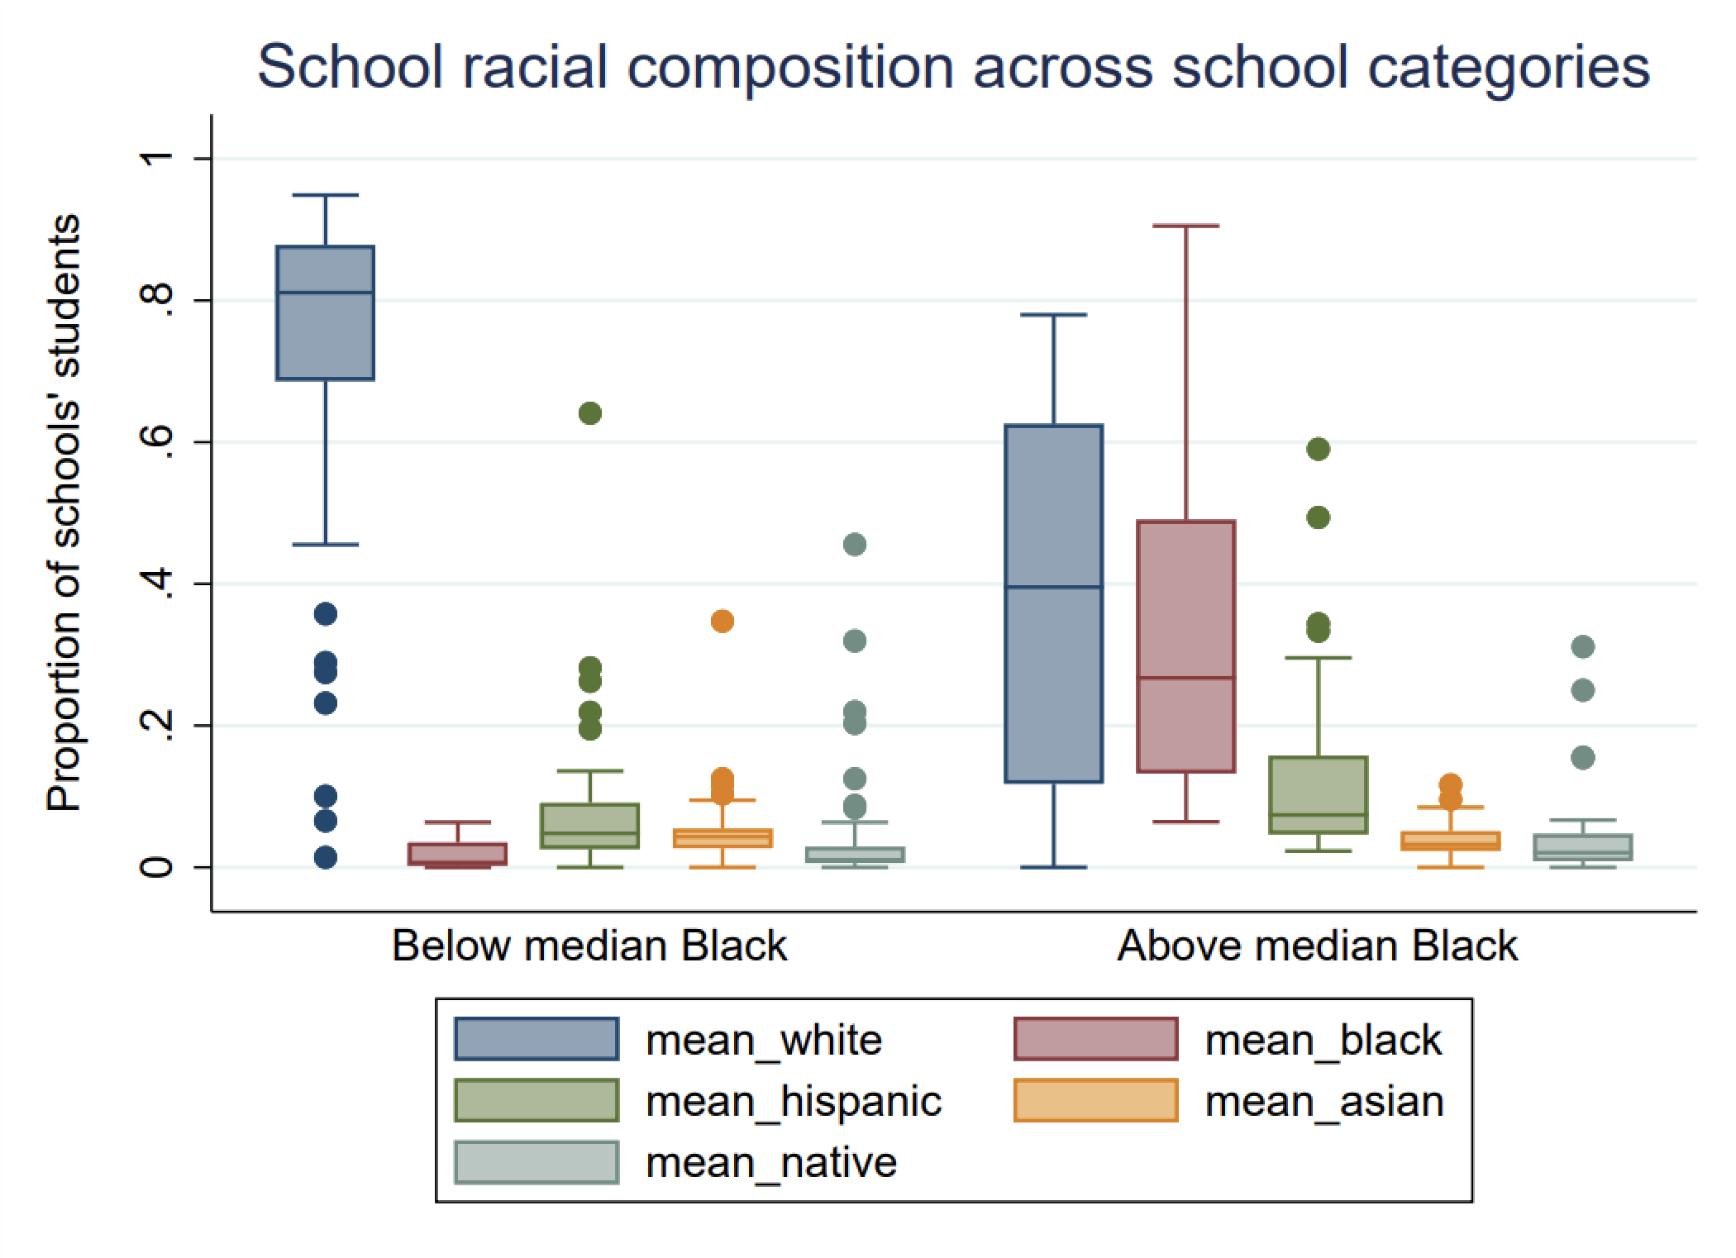

In contrast, ‘above vs. below median % White’ separated schools clearly (Figure e3). All schools above the median overwhelmingly served White students. In contrast, the average school below the median served about a third White students, about a third Black students, and about a third Asian/Pacific Islander, Hispanic, and Native American students. Few schools in this category were more than 50% White, and no school was more than about 2/3 White.

Figure e3. Distribution of school racial compositions (at the school level), by whether they were above vs. below the median % White

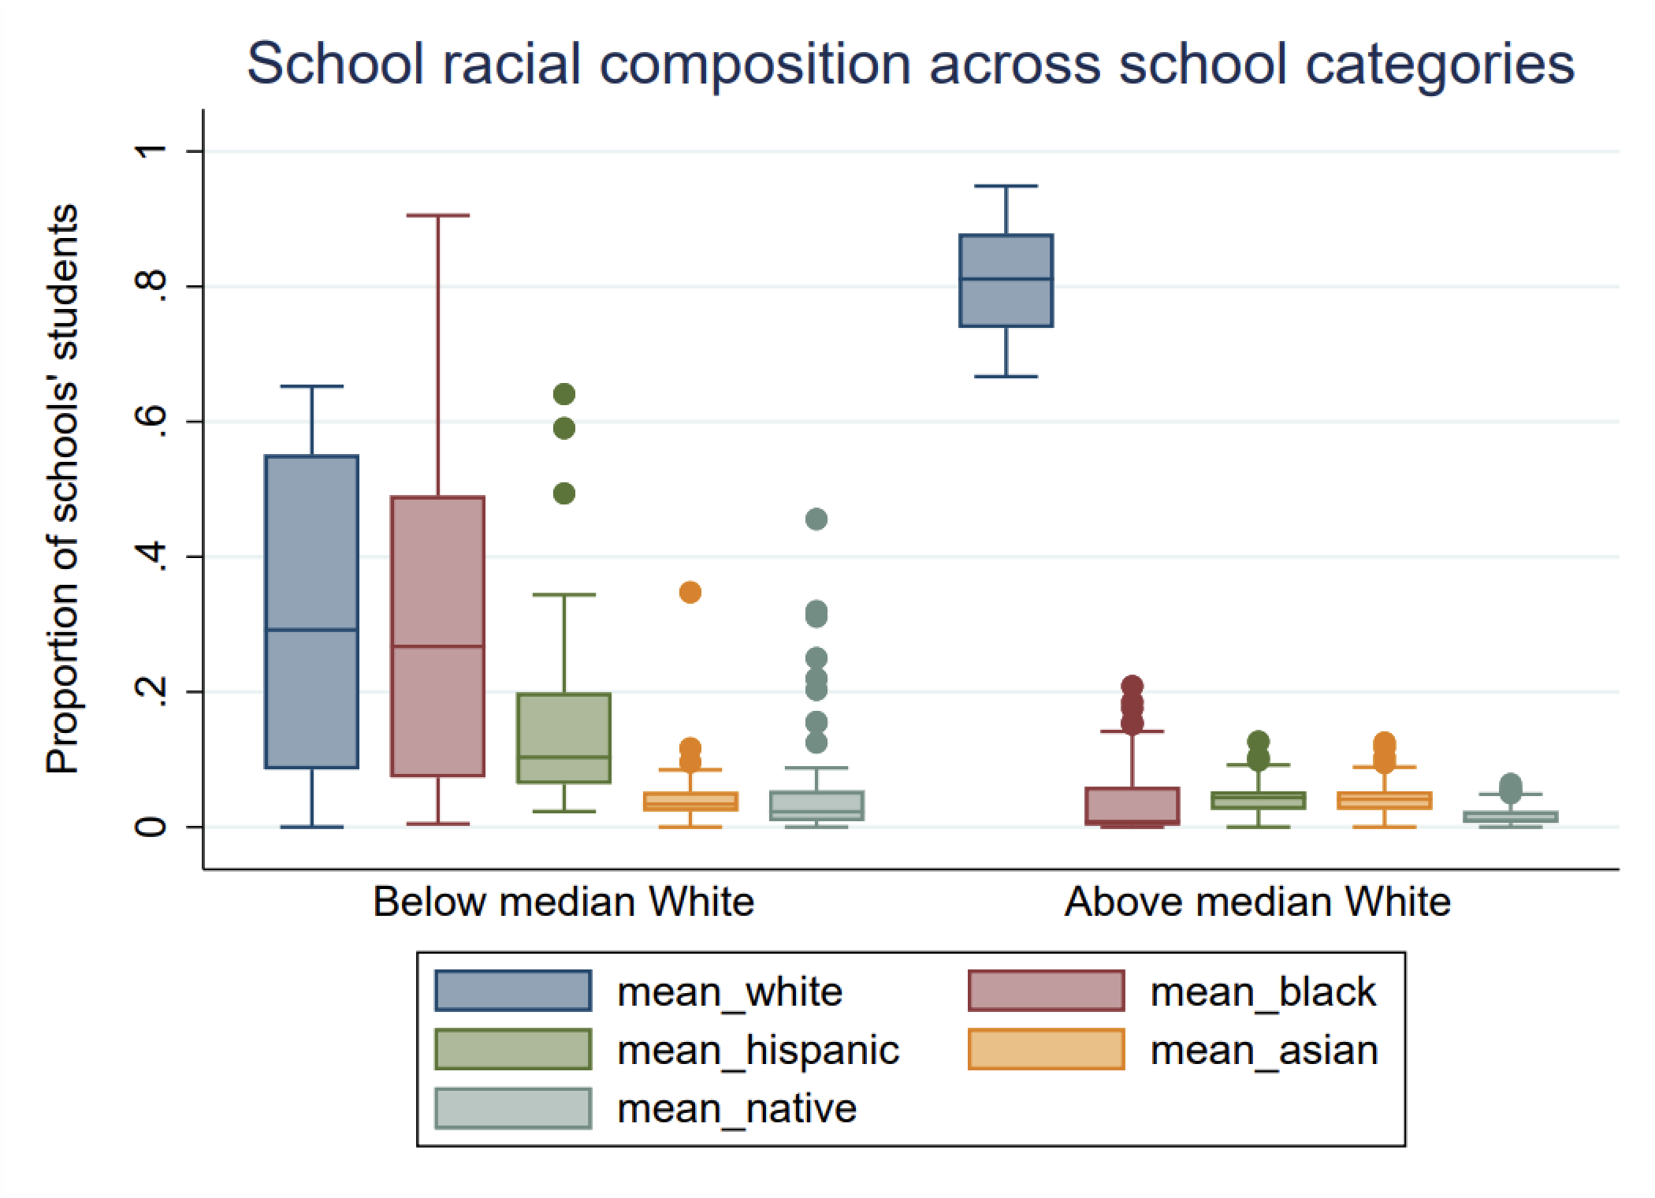

Both to maximize power and clearly separate schools by which kind of students they served, we thus chose to use above vs. below median % White.

Appendix III.
Measurement analysis: perceived prejudice and feelings of exclusion

Add Health’s in-school questionnaire included six questions measuring students’ experiences of exclusion and belonging at school, asking how strongly they agreed or disagreed with the following statements on a 5-point Likert scale:

- “I feel like I am part of the school.”
- “The students at this school are prejudiced.”
- “The teachers at this school treat students fairly.”
- “I feel socially accepted at this school.”
- “I am happy to be at this school.”
- “I feel safe at this school.”

As all of these questions measure an aspect of social exclusion, we performed reliability checks and a factor analysis to assess whether these items could be added together into a single scale.
First, we examined a correlation matrix of these six indicators (Table e4). All six were correlated with one another with a $ρ$ of between 0.27 and 0.61—except for Question 2, which was correlated at only between 0.05 and 0.14 (depending on the indicator). This indicated that Question 2, on perceptions of peer prejudice, may not serve as an indicator for the same underlying, latent exclusion factor we were hoping to measure.

Table e2. Correlation matrix between exclusion questions

 | Q1 | Q2 | Q3 | Q4 | Q5 | Q6
Q1 | 1.00
Q2 | 0.09 | 1.00
Q3 | 0.34 | 0.13 | 1.00
Q4 | 0.50 | 0.05 | 0.27 | 1.00
Q5 | 0.61 | 0.14 | 0.41 | 0.42 | 1.00
Q6 | 0.41 | 0.14 | 0.36 | 0.38 | 0.44 | 1.00

Second, we calculated Cronbach’s $α$, a measure of internal consistency reliability. This is a summary measure assessing whether individuals tend to answer these indicators similarly, or whether the questions ‘hang together’ as a coherent scale.¹ Cronbach’s $α$ values range from between 0 (indicators are completely unrelated) and 1 (perfect internal consistency), and is calculated as:

$$α=\left(\frac{k}{k-1}\right)\left(1-\frac{\sum_{i=1}^{k}{σ_{y_{i}}^{2}}}{σ_{x}^{2}}\right)$$

where k represents the number of items, $σ_{y_{i}}^{2}$ represents the variance of item i, and $σ_{x}^{2}$ represents the variance of the total scale score. A value above 0.7 is considered acceptable for a validated scale, indicating that the total variance is largely accounted for by the covariances between the items (as opposed to the variance of each individual item, separately from the others). We calculated Cronbach’s $α$ overall—across all 6 items—as well as recalculated it after removing each item in turn and calculating $α$ only among the remaining 5 items. If an indicator measures the same underlying factor as the rest of the indicators in a scale, removing it from the Cronbach’s $α$ calculation will mechanically lower the $α$ score. But if an individual item shares little covariance with the other items in the scale, removing it will increase Cronbach’s $α$ as calculated among the remaining items.
Overall, Cronbach’s $α$ was 0.73 using all six items. Removing any individual item lowered $α$ to between 0.64 and 0.70—except for Question 2. When Question 2 was removed, the scale’s $α$ value increased to 0.78. This indicated again that Question 2 contained distinct information from the remaining items.

Third, we performed a factor analysis. To do so, we split the full in-school sample (included if they had complete data on all six inclusion and belonging questions; n=72,670) into two random halves of 36,335 individuals each. With the first half, we performed an exploratory factor analysis, examining the number of factors (underlying latent variables) these items loaded onto. With the second half, we performed a confirmatory factor analysis to test whether the exploratory factor model with the best fit (that minimized factor cross-loading, e.g.) fit well in out-of-sample validation data (the second half of our split sample).
An initial exploratory factor analysis on the first half of our sample yielded a scree plot ² with strong evidence for a 1-factor model, using the rule that factors should have an eigenvalue of at least 1 (Figure e4).

Figure e4. Scree plot of eigenvalues from an exploratory factor analysis of 6 exclusion items

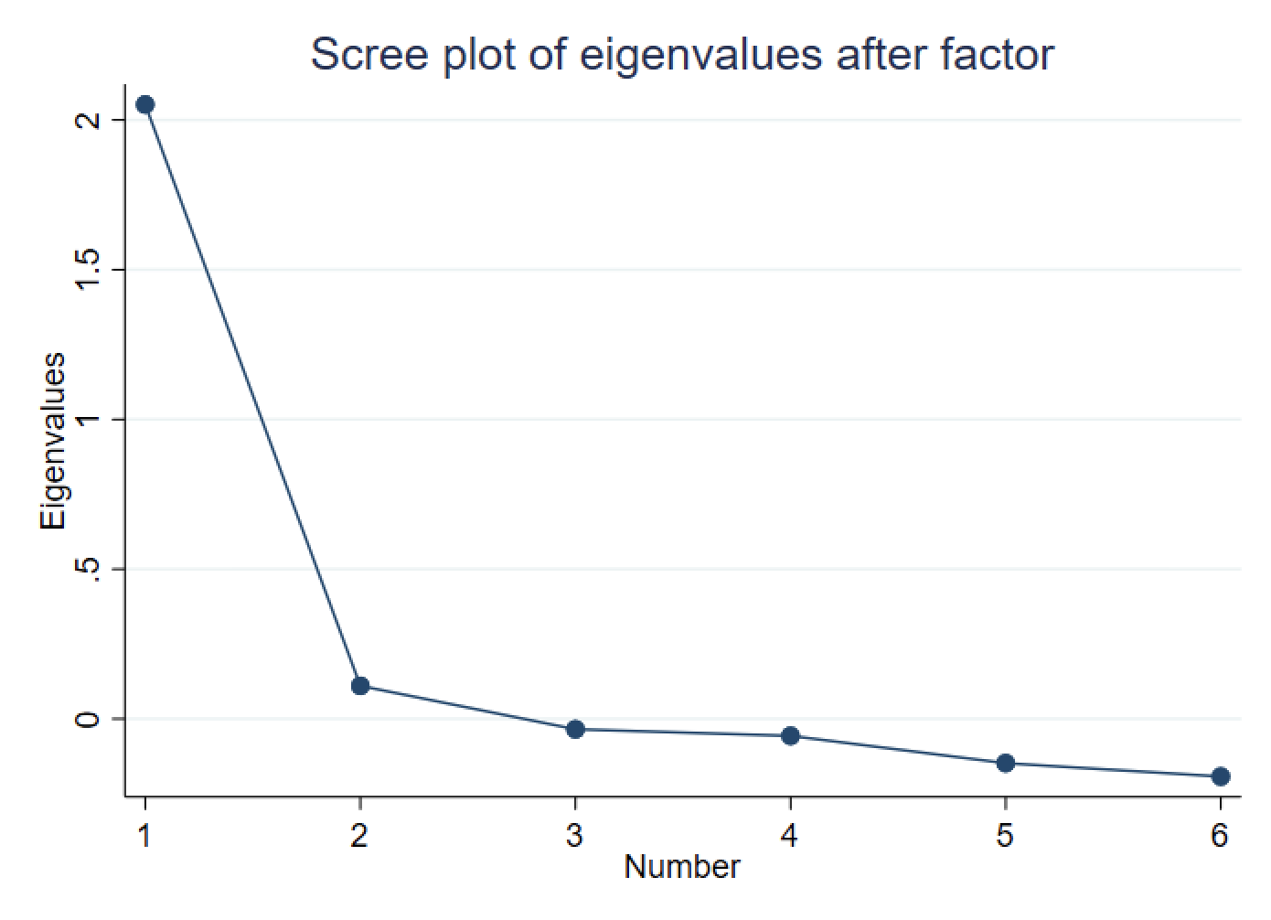

Re-fitting the model limiting it to a single factor yielded strong loadings for all indicators of between 0.51 and 0.73—except for Question 2, with a factor loading of just 0.18 (Table e5).

Table e3. Exploratory factor analysis loadings for a 1-factor model

Indicator | Loadings | Uniqueness
Q1 | 0.73 | 0.47
Q2 | 0.18 | 0.97
Q3 | 0.51 | 0.74
Q4 | 0.59 | 0.65
Q5 | 0.73 | 0.46
Q6 | 0.58 | 0.66

A two-factor model with promax rotation showed that all but one indicator (Question 2) loaded strongly onto the first factor (Table e6). Question 2, in contrast—which asked about perceptions of prejudice from other students—effectively did not load onto Factor 1 at all, but instead loaded strongly onto a second factor. Questions 3 and 6, which asked about perceptions of teacher fairness and feelings of safety at school respectively, loaded equally onto both factors, suggesting the data could plausibly be accounted for with one factor that measured feelings of exclusion at school (Questions 1, 3, 4, 5, and 6) and a second factor measuring whether students felt they were treated without prejudice, or fairly, at school (Question 2, with some cross-loading from Questions 3 and 6), with the two factors correlated at 0.62.

Table e4. Exploratory factor analysis loadings for a 2-factor model

Indicator | Loadings |  | Uniqueness
 | Factor 1 | Factor 2
Q1 | 0.74 | 0.01 | 0.45
Q2 | -0.05 | 0.30 | 0.93
Q3 | 0.27 | 0.32 | 0.72
Q4 | 0.62 | -0.03 | 0.63
Q5 | 0.62 | 0.17 | 0.46
Q6 | 0.38 | 0.27 | 0.65

Given our correlation matrix, Cronbach’s $α$ findings, scree plot, and the results of our 1- and 2-factor-restsricted exploratory models, we opted to treat Question 2 as its own outcome and move forward to confirmatory factor analysis testing only the fit of a 5-item “feelings of exclusion” scale.

Our confirmatory factor analysis indicated this 5-indicator exclusion scale fit reasonably well to our data. Excepting the p-value of our $χ^{2}$ statistic testing whether our predicted and observed data differed at all (p<0.001, likely a reflection of our very large sample size), remaining goodness of fit statistics were in a good or at least acceptable range, with a Tucker-Lewis index value of 0.936, a comparative fit index of 0.968, a root mean square error of approximation value of 0.093, and a standardized root mean squared residual of 0.031.³ We thus extracted underlying factor scores from this confirmed model for all members of our in-school sample, allowing us to extract the “true” underlying variation in Add Health participants’ feelings of exclusion and leaving behind measurement error. We then used this extracted factor score in sensitivity analyses (see Supplement V).

Appendix IV.
Sensitivity analyses

We performed sensitivity analyses in which we examined alternative measures of our outcomes. This included using more holistic measures of exclusion and belonging (as opposed to students’ reports about peer prejudice) as well as student reports about the health behaviors of their close friends (as opposed to measuring the health behaviors of their broader friend networks).

- Feelings of exclusion

Feelings of exclusion and belonging were measured using a set of 5 questions which we treated as loading onto a single factor; we used factor analysis models to extract underlying factor values (see Appendix III). Associations between school segregation and broader feelings of exclusion were largely statistically insignificant and close to 0 across all school composition categories and racial/ethnic There was one important exception: among non-Black students of color, higher segregation was associated with lower odds of experiencing feelings of exclusion in schools that largely served students of color groups (Figure e5).

Figure e5. Associations between school segregation and feelings of exclusion, by race and school racial composition

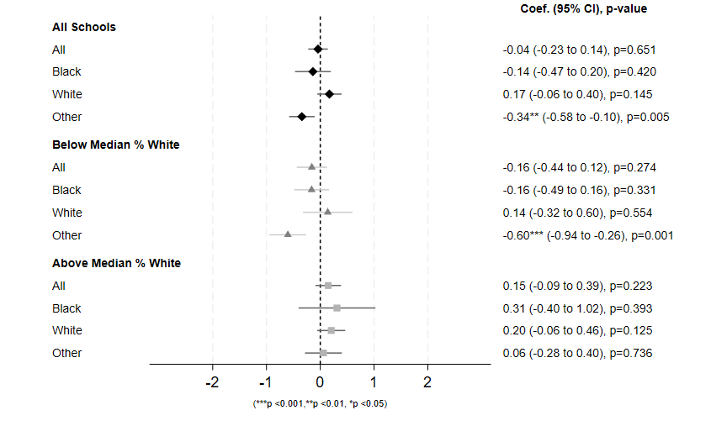

Note: Estimates were calculated using fully adjusted multilevel models (students nested within schools nested within districts), analyzing data from Add Health’s in-school sample (n=53,275). All estimates represent the change associated with a 1-unit change in the dissimilarity index. “Other” represents non-Black students of color. *** p<0.001, ** p<0.01, * p<0.05.

- Peer Health Behaviors: Close Friends

For alternative measures of peers’ health behaviors, we used data from Wave 1 of Add Health’s smaller, in-home survey. This survey (collected just after the 1994-1995 school year; starting n=20,745) included questions about the health behaviors of respondents 3 closest friends. Information on the behaviors of respondents’ close social networks may matter uniquely, as close friends may be more impactful for shaping individuals’ health behaviors.⁴⁻⁶ Here, we created two binary outcomes: whether at least one of respondents’ 3 closest friends (1) smoked cigarettes or (2) drank alcohol.
Wave I sample characteristics are presented in Table e5. Demographics for the Wave 1 sample were largely similar to our in-school sample (See Table 1). In terms of outcome measures, roughly 45% and 56% of students had at least one close friend (of their three closest) who smoked and drank, respectively. These rates were somewhat higher in predominantly White schools and lower in schools with more students of color.

Table e5. Wave I Sample Characteristics

Variable | School Type
 | All | Below Median % White | Above Median % White
Exposure
School segregation (B-W Dissimilarity index) | 0.37 (0.21) | 0.42 (0.23) | 0.30 (0.15)
Outcomes
At least one close friend smoked | 44.6% | 40.5% | 49.7%
At least one close friend drank | 56.3% | 53.9% | 59.2%
Covariates
Grade
7 | 14.3% | 13.3% | 15.6%
8 | 14.0% | 13.0% | 15.3%
9 | 18.5% | 17.5% | 19.8%
10 | 20.1% | 21.1% | 18.9%
11 | 18.1% | 19.5% | 16.4%
12 | 14.9% | 15.7% | 13.9%
Race/ethnicity
Non-Hispanic White | 53.50% | 27.00% | 86.00%
Non-Hispanic Black | 20.60% | 33.40% | 4.80%
Other | 25.90% | 39.60% | 9.10%
Age | 15.6 (1.7) | 15.6 (1.7) | 15.5 (1.7)
Sex - Female | 50% | 50.2% | 49.60%
Parental income | 43.68 (43.29) | 38.84 (37.88) | 49.60 (48.46)
Parental age | 41.73 (6.71) | 42.04 (7.22) | 41.36 (6.00)
Parental race/ethnicity
Non-Hispanic White | 53.50% | 27% | 86%
Non-Hispanic Black | 20.60% | 33.40% | 4.80%
Other | 25.90% | 39.60% | 9.10%
Parental marital status
Single | 6% | 9.10% | 2.10%
Married | 69.80% | 64.10% | 76.80%
Widowed, divorced, or separated | 24.20% | 26.80% | 21%)
Parental education
< High school | 16.90% | 22.40% | 10.30%
High school graduate or ged | 29.30% | 26.50% | 32.80%
Some college | 30.90% | 29.10% | 33.20%
College graduate or more | 22.80% | 22% | 23.80%
School region
Northeast | 23.5% | 35.0% | 9.6%
South | 24.5% | 11.7% | 40.3%
Midwest | 38.5% | 45.2% | 30.3%
West | 13.4% | 8.3% | 19.8%
School metropolitan location
Urban | 27.2% | 40.2% | 11.4%
Suburban | 55.1% | 51.0% | 60.1%
Rural | 17.7% | 8.9% | 28.5%
Proportion persons below poverty level in 1989 | 0.14 (0.12) | 0.18 (0.13) | 0.11 (0.09)
District residential segregation | 0.43 (0.24) | 0.52 (0.24) | 0.31 (0.19)
District enrollment size | 100244.0 (189021.4) | 174999.0 (228352.0) | 8592.2 (18829.4)
# of districts | 73 | 36 | 37
# of schools | 121 | 61 | 60
# of students | 12,793 | 7046 | 5747
Note: Data drawn from Add Health’s Wave I sample; n=12,793.

In regression analyses, higher segregation was associated with close friends’ health behaviors for only one group: Black children attending schools predominantly serving students of color. For these students, higher segregation was associated with lower odds of having a close friend who smoked or drank (Figure e6, panels I & II).

Figure e6. Associations between school segregation and students’ close friends’ health behaviors, by race and school racial composition

I. Whether at least one close friend smoked

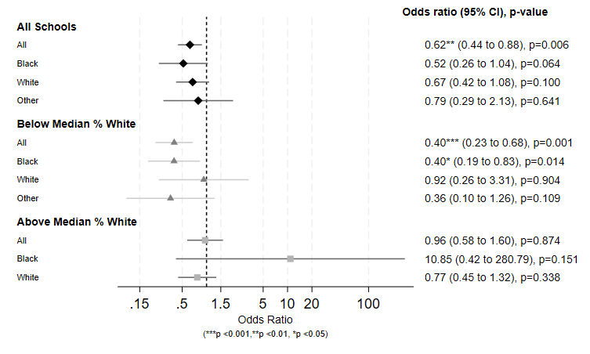

Note: n=12,793. Data drawn from Add Health Wave I sample. Results for non-Hispanic Black students have extremely large CIs that run off the page due to due to small sample sizes (n=272 for non-Hispanic Black). Results for non-Black students of color in the above-median-%-White schools were missing in this graph because the model did not converge (n=501for non-Black students of color total). All estimates represent the change associated with a 1-unit change in the dissimilarity index. “Other” represents non-Black students of color. *** p<0.001, ** p<0.01, * p<0.05.

II. Whether at least 1 close friend drank

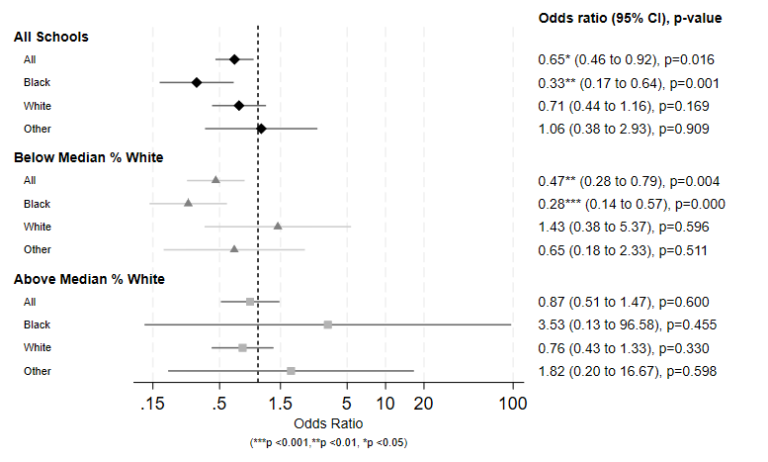

Note: n=12,793. Data drawn from Add Health Wave I sample. Results for non-Hispanic Black students and non-Black students of color in the above-median-%-White schools have large CIs due to small sample sizes (n=268 for non-Hispanic Black, n=495 for other racial/ethnic groups). All estimates represent the change associated with a 1-unit change in the dissimilarity index. “Other” represents non-Black students of color. *** p<0.001, ** p<0.01, * p<0.05.

Table e6. Missing-ness check: Peer network health behaviors

The results below are from models that estimate standard errors via a cluster-robust sandwich estimator, run on complete cases vs. on imputed data. Though these models have less desirable properties than the multilevel models we present in the main text, comparing imputed to complete case results is instructive for assessing the potential impact of data missing-ness on our results.

Data Analyzed | School Type | Race/ Ethnicity | Smoking frequency |  |  | Ever drank alcohol |  |  | Drinking frequency |  |  | Frequency of drinking until drunk
 |  |  | Coef. | 95% CI | p | Coef. | 95% CI | p | Coef. | 95% CI | p | Coef. | 95% CI | p
Imputed | All Schools | All | -0.30 | (-0.53, -0.07) | 0.012 | -0.04 | (-0.14, 0.06) | 0.432 | -0.09 | (-0.44, 0.27) | 0.628 | -0.02 | (-0.28, 0.23) | 0.851
 |  | Black | -0.09 | (-0.44, 0.26) | 0.622 | -0.06 | (-0.16, 0.04) | 0.239 | -0.24 | (-0.74, 0.26) | 0.347 | -0.18 | (-0.56, 0.19) | 0.329
 |  | White | -0.29 | (-0.64, 0.05) | 0.095 | -0.03 | (-0.16, 0.10) | 0.642 | -0.02 | (-0.43, 0.38) | 0.907 | 0.10 | (-0.19, 0.39) | 0.504
 |  | Other | -0.17 | (-0.60, 0.26) | 0.435 | -0.06 | (-0.19, 0.07) | 0.395 | 0.00 | (-0.49, 0.48) | 0.984 | 0.00 | (-0.36, 0.37) | 0.980
 | Below Median White | All | -0.52 | (-0.86, -0.19) | 0.003 | -0.05 | (-0.16, 0.07) | 0.408 | -0.19 | (-0.74, 0.37) | 0.497 | -0.15 | (-0.54, 0.24) | 0.435
 |  | Black | -0.19 | (-0.58, 0.20) | 0.330 | -0.08 | (-0.19, 0.03) | 0.146 | -0.30 | (-0.87, 0.27) | 0.290 | -0.25 | (-0.68, 0.18) | 0.241
 |  | White | FAILED TO CONVERGE
 |  | Other | -0.44 | (-1.01, 0.12) | 0.120 | -0.08 | (-0.26, 0.10) | 0.364 | -0.12 | (-0.80, 0.55) | 0.711 | -0.13 | (-0.64, 0.39) | 0.614
 | Above Median White | All | -0.01 | (-0.40, 0.38) | 0.960 | -0.01 | (-0.17, 0.14) | 0.850 | 0.04 | (-0.42, 0.50) | 0.848 | 0.11 | (-0.26, 0.48) | 0.557
 |  | Black | 1.70 | (0.22, 3.18) | 0.025 | 0.42 | (0.19, 0.64) | 0.001 | 1.33 | (-0.07, 2.74) | 0.062 | 1.01 | (-0.40, 2.42) | 0.154
 |  | White | -0.13 | (-0.50, 0.25) | 0.500 | -0.03 | (-0.18, 0.12) | 0.698 | 0.00 | (-0.45, 0.44) | 0.988 | 0.07 | (-0.31, 0.45) | 0.702
 |  | Other | 0.41 | (-0.12, 0.94) | 0.127 | 0.03 | (-0.13, 0.18) | 0.722 | 0.23 | (-0.34, 0.8) | 0.415 | 0.26 | (-0.25, 0.76) | 0.304
Complete Cases | All Schools | All | -0.29 | (-0.51, -0.06) | 0.015 | -0.04 | (-0.13, 0.05) | 0.380 | -0.29 | (-0.51, -0.06) | 0.015 | 0.03 | (-0.22, 0.29) | 0.805
 |  | Black | 0.02 | (-0.34, 0.39) | 0.890 | -0.07 | (-0.17, 0.03) | 0.159 | 0.02 | (-0.34, 0.39) | 0.890 | -0.11 | (-0.49, 0.27) | 0.555
 |  | White | -0.36 | (-0.71, -0.01) | 0.045 | -0.04 | (-0.15, 0.08) | 0.532 | -0.36 | (-0.71, -0.01) | 0.045 | 0.11 | (-0.20, 0.42) | 0.491
 |  | Other | -0.17 | (-0.70, 0.37) | 0.533 | -0.02 | (-0.14, 0.09) | 0.655 | -0.17 | (-0.70, 0.37) | 0.533 | 0.01 | (-0.42, 0.45) | 0.954
 | Below Median White | All | -0.50 | (-0.84, -0.16) | 0.006 | -0.03 | (-0.14, 0.09) | 0.606 | -0.09 | (-0.70, 0.51) | 0.764 | -0.07 | (-0.51, 0.38) | 0.766
 |  | Black | -0.07 | (-0.46, 0.32) | 0.708 | -0.09 | (-0.21, 0.02) | 0.116 | -0.30 | (-0.86, 0.25) | 0.276 | -0.19 | (-0.62, 0.23) | 0.365
 |  | White | -0.63 | (-1.72, 0.45) | 0.245 | 0.09 | (-0.12, 0.31) | 0.394 | 0.52 | (-0.46, 1.49) | 0.291 | 0.52 | (-0.32, 1.35) | 0.216
 |  | Other | -0.69 | (-1.34, -0.04) | 0.039 | -0.04 | (-0.20, 0.12) | 0.619 | 0.06 | (-0.76, 0.87) | 0.891 | -0.22 | (-0.90, 0.46) | 0.521
 | Above Median White | All | -0.02 | (-0.40, 0.35) | 0.895 | -0.04 | (-0.17, 0.08) | 0.474 | -0.02 | (-0.44, 0.4) | 0.925 | 0.13 | (-0.24, 0.50) | 0.492
 |  | Black | 2.42 | (0.49, 4.35) | 0.016 | 0.46 | (0.27, 0.64) | < 0.001 | 1.82 | (0.30, 3.34) | 0.021 | 1.68 | (-0.09, 3.44) | 0.062
 |  | White | -0.21 | (-0.56, 0.15) | 0.247 | -0.06 | (-0.19, 0.06) | 0.318 | -0.10 | (-0.52, 0.32) | 0.642 | 0.06 | (-0.33, 0.46) | 0.751
 |  | Other | 0.92 | (0.46, 1.38) | < 0.001 | 0.04 | (-0.08, 0.15) | 0.515 | 0.38 | (-0.14, 0.89) | 0.144 | 0.45 | (0.00, 0.90) | 0.051

Table e7. Missing-ness check: Peer prejudice

The results below are from models that estimate standard errors via a cluster-robust sandwich estimator, run on complete cases vs. on imputed data. Though these models have less desirable properties than the multilevel models we present in the main text, comparing imputed to complete cases results is instructive for assessing the potential impact of data missing-ness on our results

Data Analyzed | School Type | Race/ Ethnicity | Coef. | 95% CI | p
Imputed | All Schools | All | 0.43 | (0.24, 0.75) | 0.003
 |  | Black | FAILED TO CONVERGE
 |  | White | 0.53 | (0.28, 1.01) | 0.052
 |  | Other | 0.46 | (0.25, 0.85) | 0.013
 | Below Median White | All | 0.43 | (0.18, 1) | 0.050
 |  | Black | FAILED TO CONVERGE
 |  | White | FAILED TO CONVERGE
 |  | Other | 0.63 | (0.25, 1.59) | 0.332
 | Above Median White | All | 0.73 | (0.4, 1.33) | 0.297
 |  | Black | FAILED TO CONVERGE
 |  | White | 0.73 | (0.4, 1.35) | 0.322
 |  | Other | 0.55 | (0.3, 0.98) | 0.044
Complete Cases | All Schools | All | 0.40 | (0.23, 0.72) | 0.002
 |  | Black | 0.64 | (0.28, 1.44) | 0.280
 |  | White | 0.49 | (0.26, 0.94) | 0.032
 |  | Other | 0.38 | (0.19, 0.76) | 0.006
 | Below Median White | All | 0.41 | (0.16, 1.04) | 0.061
 |  | Black | 0.72 | (0.28, 1.86) | 0.503
 |  | White | 0.23 | (0.09, 0.61) | 0.003
 |  | Other | 0.54 | (0.19, 1.54) | 0.248
 | Above Median White | All | 0.69 | (0.38, 1.28) | 0.244
 |  | Black | 1.18 | (0.24, 5.78) | 0.842
 |  | White | 0.70 | (0.38, 1.29) | 0.254
 |  | Other | 0.46 | (0.24, 0.87) | 0.017

Appendix References

1. Tavakol M, Dennick R. Making sense of Cronbach's alpha. Int J Med Educ. 2011;2:53-55.
2. ScienceDirect. Scree Plot. https://www.sciencedirect.com/topics/mathematics/scree-plot. Published 2022. Accessed August 30, 2022.
3. Shi D, Lee T, Maydeu-Olivares A. Understanding the Model Size Effect on SEM Fit Indices. Educational and Psychological Measurement. 2019;79(2):310-334.
4. Brooks-Russell A, Simons-Morton B, Haynie D, Farhat T, Wang J. Longitudinal relationship between drinking with peers, descriptive norms, and adolescent alcohol use. Prev Sci. 2014;15(4):497-505.
5. Ivaniushina V, Titkova V. Peer influence in adolescent drinking behavior: A meta-analysis of stochastic actor-based modeling studies. PLoS one. 2021;16(4):e0250169.
6. Borsari B, Carey KB. Peer influences on college drinking: A review of the research. Journal of substance abuse. 2001;13(4):391-424.

